

**Placement Empowerment Program**

***Cloud Computing and DevOps Centre***

Automate File Copying with a Script

Create a script to copy files from one folder to another automatically.

Name: Harivasan S

Department: ADS



# Introduction:

**File transfers between directories are a frequent necessity in many workflows. Automating this task helps improve efficiency and reduces the likelihood of errors. This proof of concept (PoC) presents a simple script designed to copy files from a designated source folder to a target destination. Python handles the file transfer process, while Windows Task Scheduler automates execution at specified intervals or times.**

# Objectives :

1. **Automate File Transfers:** Develop a Python script to move files from a designated source folder to a specified destination.
2. **Set Up Scheduling:** Configure Windows Task Scheduler to execute the script automatically at chosen time intervals.
3. **Confirm Success:** Validate that files are transferred correctly and identify any errors that may occur during the process.

# Step-by-Step Overview :

## Step 1

Create two folders with name Source and Destination



## Step 2

Copy code from chatgpt to tranfer file from source to destination and we insert the path for source and destination inside that code.

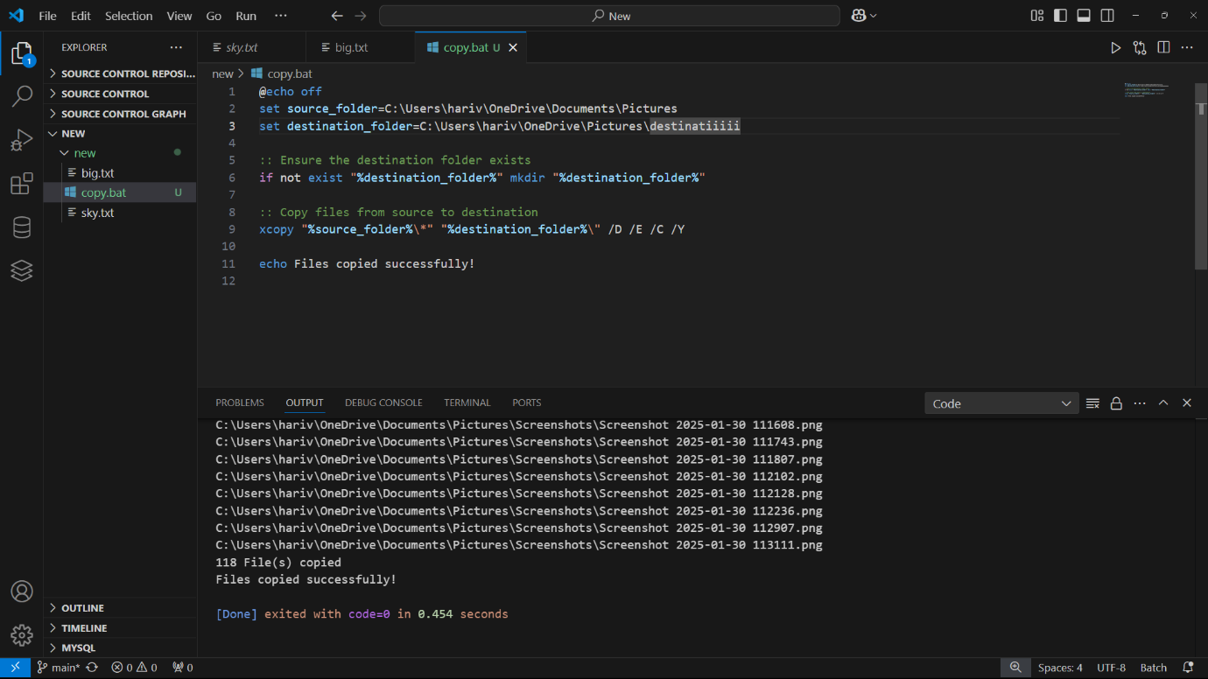

## Step 3

Save the file in desktop with .bat extension

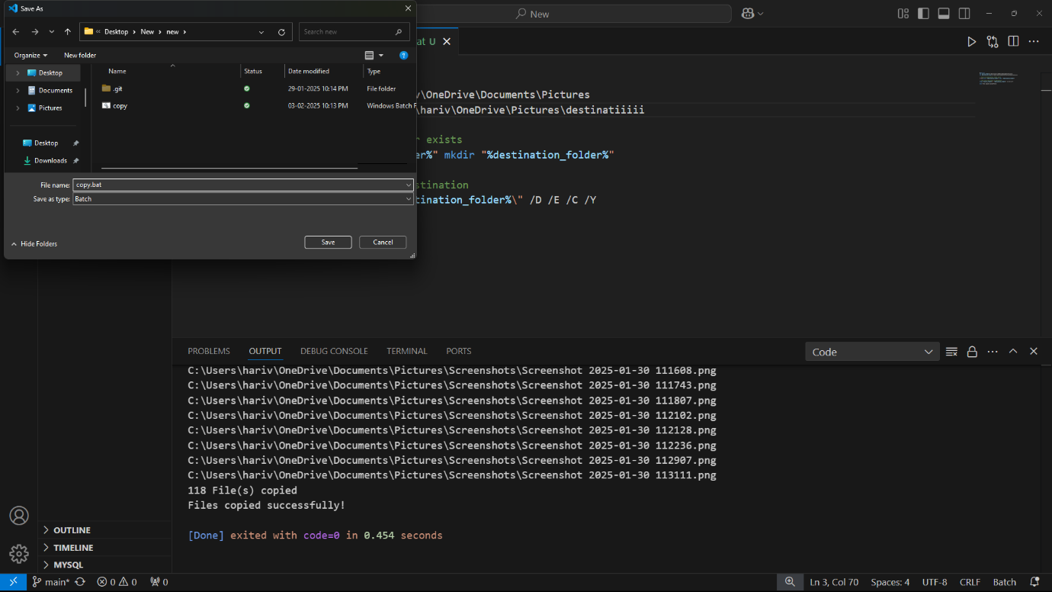

## Step 4

We run the code in Visual Studio that will transfer all the files saved in source to destination

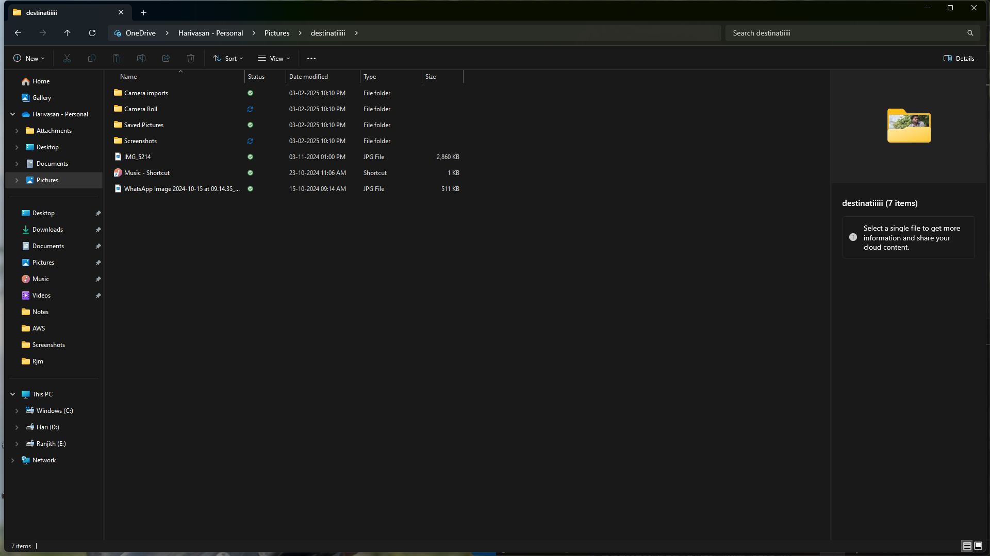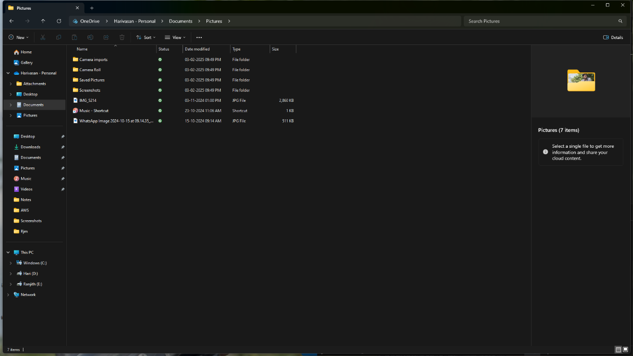

Expected outcome:

1. **Successful File Transfer:** The script copies all specified files from the source folder to the destination folder without errors.

2. **Automated Execution:** The process runs automatically at scheduled intervals using Windows Task Scheduler.

3. **Error Handling & Logging:** Any issues encountered during the transfer are logged for troubleshooting and resolution.